**Problem Statement:**

1. Write a java program to illustrate following String API methods.

charAt() , compareTo(), equals(), equalsIgnoreCase(), indexOf(), length() , substring(), toCharArray() , toLowerCase(), toString(), toUpperCase() , trim() , valueOf()

CODE:

import java.util.*;

class Strtest{

public static void main(String args[]) throws Exception{

Scanner inp = new Scanner(System.in);

String str1 = "I have become comfortably numb";

String str2 = "There is no pain you are receding";

System.out.println("First string str1 : " + str1);

System.out.println("First string str2 : " + str2);

System.out.print("Enter the index to view character : ");

int n = inp.nextInt();

System.out.println("Demonstrating charAt()");

System.out.println("Character at index " + n + " is " + str1.charAt(n));

System.out.println("---------------------------------------------");

System.out.println("Demonstrating compareTo()");

System.out.println("Comparing str1 and str2 : " + str1.compareTo(str2));

System.out.println("---------------------------------------------");

System.out.println("Demonstrating equals()");

System.out.println("Checking if str1 and str2 are equal : " + str1.equals(str2));

System.out.println("---------------------------------------------");

System.out.println("Demonstrating equalsIgnoreCase()");

System.out.println("Checking if str1 and str2 are equal ( case irrespective) : " + str1.equalsIgnoreCase(str2));

System.out.println("---------------------------------------------");

System.out.println("Demonstrating indexOf()");

System.out.print("Enter the substring to view index : ");

String nstr = inp.nextLine();

System.out.println("using indexOf() on substring : " + str1.equalsIgnoreCase(nstr));

System.out.println("---------------------------------------------");

System.out.println("Demonstrating length()");

System.out.println("Length of str1 is : " + str1.length());

System.out.println("Length of str2 is : " + str2.length());

System.out.println("---------------------------------------------");

System.out.println("Demonstrating substring()");

System.out.print("Enter starting index : ");

n = inp.nextInt();

System.out.print("Enter ending index : ");

int n2 = inp.nextInt();

System.out.println("Substring of index between " + n + " & " + n2 + "is: "+ str1.substring(n,n2) + " , " + str2.substring(n,n2));

System.out.println("---------------------------------------------");

System.out.println("Demonstrating toCharArray()");

System.out.println("Using equals to show that a string and a string converted to character array are different : ");

System.out.println("str1.equals(str1.toCharArray()) : " + str1.equals(str1.toCharArray()));

System.out.println("---------------------------------------------");

System.out.println("Demonstrating toUpperCase() and toLowerCase()");

System.out.println("Uppercase of str1 : " + str1.toUpperCase());

System.out.println("Lowercase of str1 : " + str1.toLowerCase());

System.out.println("---------------------------------------------");

System.out.println("Demonstrating toString()");

System.out.print("Enter a number : ");

Integer n3 = inp.nextInt();

System.out.println("Getting runtime class after using toString() : " + n3.toString().getClass() );

System.out.println("---------------------------------------------");

System.out.println("Demonstrating trim()");

String str = " Hello World !! ";

System.out.println("String is : " + str);

System.out.println("String after usng trim() : " + str.trim());

System.out.println("---------------------------------------------");

System.out.println("Demonstrating valueOf()");

System.out.print("Enter a number : ");

n2 = inp.nextInt();

System.out.println("Converting number to string and concatenatng : " + String.valueOf(n2) + 10);

System.out.println("---------------------------------------------");

}

}

OUTPUT:

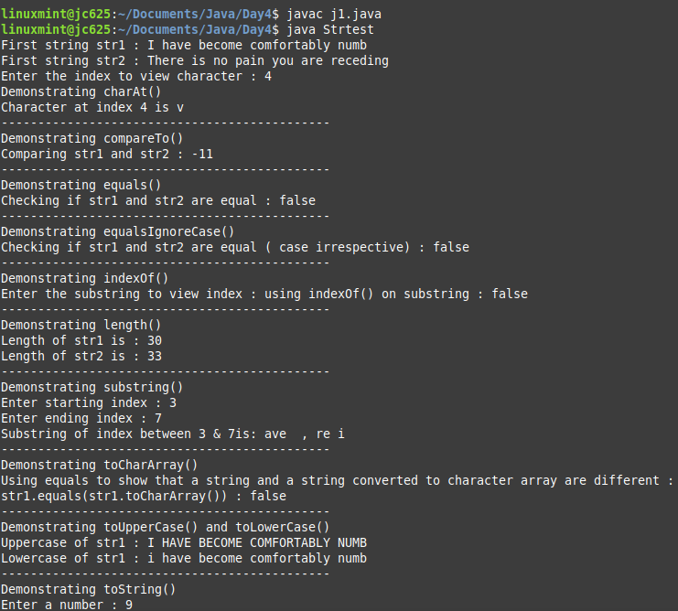

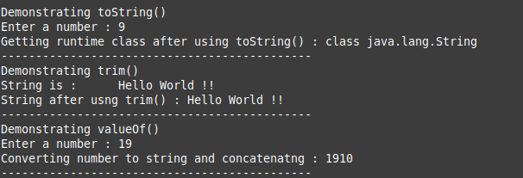

2. Write a java program to illustrate following StringBuffer API methods.

append(), capacity(), charAt(), delete(), deleteCharAt(), ensureCapacity(), getChars(),

indexOf(), insert(), length(), setCharAt(), setLength(), substring(), toString() methods),

CODE:

class StringBufferExample{

public static void main(String args[]){

Scanner sc=new Scanner(System.in);

System.out.println("Enter the String: ");

String s=sc.nextLine();

StringBuffer s1 = new StringBuffer(s);

System.out.println("append(): "+s1.append("Hello"));

System.out.println("capacity(): "+s1.capacity());

System.out.println("charAt(): "+s1.charAt(0));

System.out.println("delete(): "+s1.delete(1,2));

System.out.println("deleteCharAt(): "+s1.deleteCharAt(0));

s1.ensureCapacity(100);

System.out.println("ensureCapacity(): "+s1.capacity());

System.out.println("indexOf(): "+s1.indexOf("w"));

System.out.println("insert(): "+s1.insert(5,"Hello"));

System.out.println("length(): "+s1.length());

s1.setCharAt(2,'e');

System.out.println("setCharAt(): "+s1);

s1.setLength(30);

System.out.println("setLength(): "+s1.length());

System.out.println("substring(): "+s1.substring(2,6));

System.out.println("toString(): "+s1.toString());

}

}

OUTPUT:

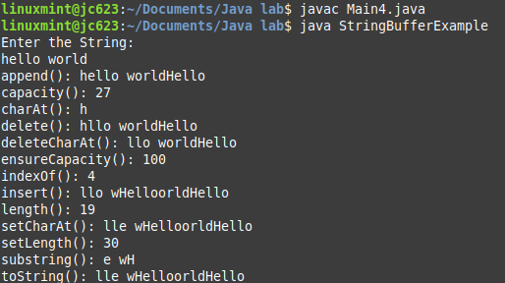

3. Write a java program for explaining the concept of mutable and immutable string.

CODE :

class MutImmut{

public static void main(String args[]){

String s="Hello";

s.concat(" Hi");

System.out.println("Immutable : "+s);

StringBuffer s1=new StringBuffer("Hello");

s1.append(" Hi");

System.out.println("Mutable : "+s1);

}

}

OUTPUT:

